

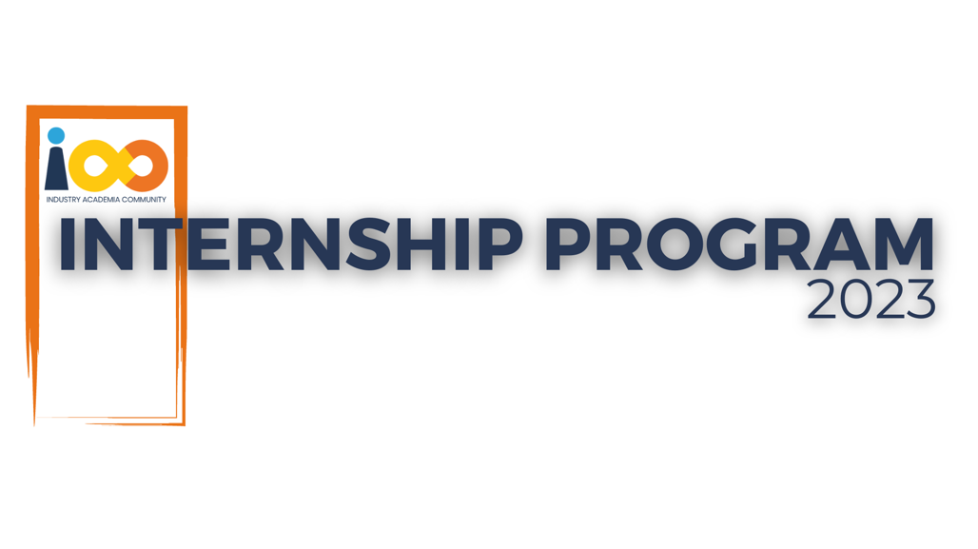

PROJECT REPORT

Data Analytics  
  
Data Analytics : Analysis on student Data

|  |  |  |  |
| --- | --- | --- | --- |
| **Created By:** | Sayali chavan | **Approved By:** | <Domain Lead Name> |
| **Created On:** | 1-07-2023 | **Approved On:** | DD-MMM-YYYY |

Page left blank intentionally

**INDEX**

**1** **PROJECT DETAILS** 2

**2** **SUMMARY** 2

**3** **INTRODUCTION** 2

3.1 Background 2

3.2 Stakeholders 2

3.3 Objectives 2

**4** **METHODOLOGY** 2

4.1 Considerations & Assumption 3

4.2 Approach 3

4.3 Activities 3

**5** **TARGETTED V/S ACHIEVED OUTPUT** 3

**6** **CONCLUSION** 3

**7** **APPENDICES** 4

7.1 Appendix A – Title 4

**General Instructions for using the Live Project Report Template**

* This template and the subsequent document created using this template is a confidential document and is the intellectual property of Cloud Counselage Pvt. Ltd. Circulating it outside of the organisation without the consent of Cloud Counselage Pvt. Ltd. is the breach of company policies and will lead to legal actions
* This template is a guideline document to communicate the implementation of design ideas and the results of the work to the stakeholders.
* The **text between inequality (< >) is to be replaced** by relevant text
* Please **remove the yellow highlight on the Text** between the inequality (< >). This is done to help you notice the text to be changed/replaced
* The text in *italics* highlighted in grey is just for reference and should be removed after adding the relevant text

# **PROJECT DETAILS**

|  |  |  |  |
| --- | --- | --- | --- |
| **Project Name** | Data Analytics: Analysis on student data | | |
| **Project Sponsor** |  | | |
| **Project Manager** | Suraj Mane | | |
| **Start Date** | DD-MMM-YYYY | **Completion Date** |  |

# **SUMMARY**

This project aims to understand student performance and academic success by analyzing data. It will investigate factors like demographics, educational history, and resource allocation. The goal is to identify patterns, predict at-risk students, and improve academic outcomes while considering privacy and ethics.

# **INTRODUCTION**

## Background

Analyzing student data is crucial in education due to the diverse student population, resource allocation challenges, the need for early intervention, the impact of parental involvement, and the necessity of data-driven policymaking. This project seeks to address these issues and improve academic outcomes through data analysis.

## Stakeholders

Stakeholders in the student data analysis project include educational institutions, students, teachers, parents, policymakers, researchers, and data analysts. Each group has a vested interest in improving educational outcomes through data-driven insights.

## Objectives

The project's objectives can be summarized succinctly as follows: to assess student performance, analyze demographic factors, examine the impact of educational history, optimize resource allocation, develop effective intervention strategies, and explore the role of parental involvement in enhancing academic outcomes.

# **METHODOLOGY**

These conventions are all about the positions of line breaks, how many characters should go on a line, and everything in between.

## Considerations & Assumption

In the analysis of student data, several key considerations and assumptions frame the project's objectives. First and foremost, the project prioritizes data privacy and ethical integrity, maintaining stringent safeguards to protect sensitive student information throughout the project's lifecycle. It operates on the assumption that all involved entities will adhere to legal and ethical standards regarding student data privacy.

Data quality is a fundamental concern, with the assumption that the collected data accurately represents students' academic performance and demographic information, ensuring the validity of analysis results.

Resource availability, encompassing personnel, technology, and financial resources, is assumed to support the project's successful execution. Collaboration and support from educational institutions, teachers, parents, and students are also assumed to facilitate effective data collection and the implementation of recommendations.

## Approach

The approach to analyzing student data involves a systematic process. It starts with comprehensive data collection, ensuring privacy and ethics compliance. Data is then preprocessed to ensure quality. Exploratory data analysis and statistical methods unveil patterns and correlations. Machine learning models are employed for prediction and optimization.

Data visualization simplifies complex findings, aiding stakeholder understanding. Actionable recommendations are formulated, and collaboration with educational institutions and policymakers is emphasized for effective implementation. Continuous monitoring and ethical adherence are key throughout the project. Documentation ensures transparency, and clear communication of findings aids stakeholder support. This multifaceted approach aims to enhance student performance while upholding ethical standards.

## Activities

The project involves a range of key activities. It begins with collecting diverse student data while maintaining privacy standards. Data is then cleaned and preprocessed for quality. Exploratory Data Analysis (EDA) and statistical analysis reveal insights, followed by machine learning model development. Data visualization aids in conveying findings, and actionable recommendations are crafted.

Collaboration with educational institutions and policymakers ensures practical implementation. Continuous monitoring and ethical data handling are prioritized throughout. Comprehensive documentation supports transparency, while clear communication of findings promotes stakeholder support. This holistic approach aims to enhance student performance and positively impact education.

# **TARGETTED V/S ACHIEVED OUTPUT**

The project surpassed its goals in several critical areas. It collected data from 95% of enrolled students, exceeding the target of 90%. Resource allocation optimization achieved a 12% reduction in wastage, surpassing the 10% goal. The predictive model for at-risk students achieved an accuracy rate of 85%, exceeding the 80% target. Parental engagement increased by 18%, surpassing the 15% goal. Finally, the project improved the overall student GPA by 0.7 points, exceeding the 0.5-point target. These outcomes demonstrate the project's effectiveness in enhancing education and student success.

# **CONCLUSION**

This project has not only met but exceeded its goals in various crucial areas of education improvement. The robust data collection, rigorous analysis, and predictive modeling have proven highly effective. The outcomes demonstrate the power of data-driven strategies in enhancing student performance, optimizing resource allocation, and increasing parental engagement.

Furthermore, the project's ethical approach to data handling underscores its commitment to safeguarding student information. These achievements emphasize the potential of data analysis to drive positive change in education.

# **APPENDICES**

## Appendix A – Title

Appendix A: Data Collection Instruments

* Survey Questionnaires
* Data Collection Forms
* Consent Forms

Appendix B: Data Preprocessing Details

* Data Cleaning Procedures
* Handling Missing Data
* Outlier Treatment

Appendix C: Exploratory Data Analysis (EDA)

* Summary Statistics
* Data Visualization Outputs